Cumbres & Toltec Scenic Railroad Commission

Minutes of the Regular Meeting August 10, 2024

9:03 am

DRAFT MINUTES: NOT Final until approved by the Commission

Location of Meeting:

Antonito Fire Station, 38791 Hwy 17

Antonito Colorado

Present at Meeting: Commissioner Bill Elbrock, Commissioner Scott Gibbs, Commissioner Mark Graybill, Commissioner Kim Smith Casford

Approval of Agenda: The agenda for the meeting was distributed. Motion to approve the agenda my Commission Scott Gibbs Second by Commissioner Mark Grabill

Motion to change agenda was made by Commissioner Bill Elbrock:

Delete items # 11, A, B, C,,D and # 4

Motion to approve amended agenda all Commissioner in Favor

Removed from agenda

Approval of Minutes from Regular Meeting February 17, 2024 were reviewed

New Business: None

General Managers Report: Attached As Addendum A

Superintendents Marketing Report: Attached As Addendum B

Financial Report: Attached As Addendum C

Capitol Projects Report: Attached As Addendum D

Friends of the Cumbres Toltec Scenic Railroad Report: No Attachment

Tracks across Borders: No Attachment

Old Business: None Presented

Executive Session – 9:44 No decisions made

Resume regular session all approved @ 10:10

Zoom meeting will happen soon

Motion to Adjourn

The Next regular meeting will be held on November 2, 2024 at 9:00am, location to be determined.

__________________________________

Kim Smith Casford Secretary

**Addendum A**

**Cumbres & Toltec Scenic Railroad**

**General Manager Update**

**(08 August 2024)**

**General –** With the operating season now into its eleventh week, activity has settled in throughout the railroad. No major obstacles have been encountered and operations continue with relatively few issues. As always there are some challenges, but they are being managed effectively. The Department reports provide more detail of the status of operations in each area.

**Railroad Operations –** Train operations continue to go well. Locomotives and rolling stock have been reliable and few challenges have been encountered. These were dealt with and trains are operating as planned. Locomotive #463 has been heavily used and wear in the running gear is reaching a point where it will be used sparingly until a planned rehab of the running gear is completed this winter. We continue to avoid the hot box issues on the passenger cars that are frequently observed at the beginning of a new season. The track and support structures were well prepared to start operations without slow orders and train performance has been good. Continued congratulations to everyone taking part in mechanical operations. All the efforts are paying off.

**Business Operations –** Business Operations are moving forward and there continue to be few problems since train operations began. The new Fare Harbor reservation system went live and implementation went quite smoothly. There have been a few issues with ticket sales. The built in report systems have been inadequate for a complicated business such as the C&TS with demanding government audit requirements. Business analytics is problematic as well. Custom reports have been developed to appropriately support our business model and they are now being tested. Sales to date continue and are overall up roughly 22% over comparable periods in both 2019 and 2023. Group sales continue to be strong, however FIT sales are improving but are below what we’ll need to meet our longer term financial goals. The combination of reduced coach prices for the summer and increased group sales has resulted in reduced ticket yields and weaker revenue performance. Unfortunately, correlation with overall season performance has historically been weak, but at least tickets are being sold – particularly on-line.

Marketing efforts are ongoing. Abi has presented a detailed review of where we stand currently. Last season we only carried 30.1K passengers and only 24.6K during the 2023 months of this fiscal year. The FY 24 fiscal budget anticipated 34.5K passengers and while we haven’t achieved the planned result, we have made up some ground. We ended the fiscal year at approximately 31.5K passengers. We are working hard to regain our core business performance as well as developing new products. Groups performance has been good and will be an important part of the solution. Abi continues to explore many options that will return us to our path toward self-sustainability.

Retail and On-Board operations have been successful. Kalee’s report provides details of where we now stand. Call backs and recruiting of seasonal personnel succeeded initially in providing staffing required to support operations, however attrition is resulting less than adequate personnel strength than is now needed. Human Resources is working diligently to support current and future staffing needs. Retail sales have been solid with special emphasis on maximizing net contribution to overall NOI.

**Financial –** The financial situation has improved somewhat from what it was early in the year. Three of Commission business elements remain quite healthy with solid balance sheets and P&L’s. Unfortunately, CTO continues to be significantly weakened by lower than planned ridership since the pandemic. Alysia has provided a detailed look at each of the business elements in her report. Within CTO, the P&L will show a loss. The magnitude of the loss won’t be clear until we close the books on FY 24, however it will not be as severe as had been feared. In the mean time a major effort continues to be placed on cash management and cost control.

Much of the CTO cost structure such as insurance, meal costs, motorcoach service and a variety of G&A and utility costs are not very flexible. While all expenditures are being carefully monitored, labor and marketing offer the biggest opportunities for potential cost savings to help manage cash flow. We have prepared budget plans for FY25 and will present them for Commission review and approval. Efforts to reduce labor expenditures are continuing to show signs of success. A carefully managed preparation for start up along with reduced leadership and business staffing has resulted in April through July labor costs to be measurably less than in 2023. Unfortunately, insurance costs continue to be high offsetting some of the gains in reducing labor expenses. Overall, we must continue to build our ridership performance.

Financial performance in the Capital and Commission elements of the overall enterprise is solid. Particular emphasis on utilization of ARPA funds which are most perishable is being carefully monitored. At present, actual spending of these funds has reached roughly $1.2M and another $0.4M is committed. Other significant projects are nearing the commitment stage as well. We must have all the ARPA commitments complete by year end. We have begun moving WP&Y #114 out of Alaska. The trucks are already in Antonito and the rest of the locomotive is in Wahington and is being readied for transport. We expect it to arrive in Antonito by early fall. The goal is to utilize the total amount of the ARPA funding source as quickly as possible so as to gain the benefits provided.

**Government Affairs Activities –** The long legislative season was finally completed. In New Mexico the legislature approved Commission support funding of $380K and capital funding of $2,125K. This includes all of our base request as well as additional funding to support the Chama roundhouse restoration and rebuilding of the Cumbres pavilion. We are currently in the administrative aftermath required to turn the approvals into actual funds for expenditure. Work has begun on the design of the Cumbres Pavilion replacement and engineering will soon resume on the Chama roundhouse restoration. We will have also begun the request cycle for the next legislative season. This was challenging as the Capital Outlay implementation of BFM had not gone well and it has temporarily reverted to the older CPMS. As a non-participant in the state accounting system, there have been some challenges.

In Colorado our base request for $1,365K along with a special request for $500K to mitigate the wildfire threat was included was approved and signed by the Governor. The next major task has been to work on the next “Three Year Plan”. The Colorado request has been a challenge as budget guidelines from the Governor restrict what we can request. We have, however, requested additional funding to offset the cost increases encountered over the last three years. We operated a special train in July to demonstrate to key Colorado decision makers how important the railroad is to the area. Overall, it was a successful legislative season and we hope that preparations for the next one will be successful as well.

**Summary –** An enormous amount of work continues to take place on the railroad for the ongoing operating season. There had been much pressure on the organization to get the season off to a strong start. We have accomplished much and I am pleased and thankful that we have the right people in place to continue to make it happen.

**Addendum B**

**Marketing Report**

**August 10, 2024, MARKETING CTO- COMMISSION REPORT**

Prepared August 5, 2024, by Abigail Martinez (Marketing Manager)

**EMAIL CAMPAIGN**

Below is a chart comparing email blast numbers from this season to date to prior seasons.

|  |  |  |
| --- | --- | --- |
| **Season Year** | **Open Rate** | **Click Rate** |
| 2024 | 32% | 3% |
| 2023 | 33% | 2% |
| 2022 | 29% | 3% |
| 2019 | 22% | 2% |

**DIGITAL MARKETING**

**Digital Programmatic Buy- Q1 Media**

**Performance for July 2024**

1. The campaign has delivered a total of 1,345,621 impressions with 19,174 clicks with an overall 1.42% click-through rate & 997 Conversions
2. Facebook is our top converter for July, followed by Google
   1. Google Calls: 106
   2. Google Purchases: 242
   3. Facebook Purchases: 362
3. Programmatic is our 3rd top converting tactic with a total of 287 Conversions

Compared to June 2024 total conversions, we saw a 30% increase for July!  (766 🡪 997)

With a new ticketing system, this season, our digital conversions have been ramping up each month as the pixel is being optimized and gathering data. *In July we continued to see a large difference in YOY Google conversions while ticket sales continued to be up, so we dug into how the old pixel was set up and learned it was set up (by the old vendor DTS) to count more actions than just ticket sales as conversions (such as button clicks, page views, etc.). Based on the data we have; we can see that it was tracking more actions that the current Fare Harbor pixel. The Fare Harbor pixel only counts actual ticket sales as conversions, which we believe is the best and most accurate measurement to use moving forward.*

|  |  |  |  |  |
| --- | --- | --- | --- | --- |
| **Season Year** | **Facebook Conversion** | **Google Conversions** | **Display/Video Conversion** | **Total** |
| June & July 2024 | 661 | 435 | 465 | 1561 |
| June & July 2023 | 285 | 2645 | 80 | 3010 |
| June & July 2022 | 117 | 2190 | 35 | 2342 |

**Banner Ads/Featured Listings:**

We have many banner ads and featured listings running on the following websites during the 2024 season:

TaosNews.com (*CTR =.14%),* NewMexico.org (*CTR=2.97%),* Colorado.com (*CTR=.65%),* Gazette.com, VisitAlbuquerque.org (*CTR=2.4%),* TravelNewMexico.org (*CTR =.14%),* LAdailypost.com (*CTR= .09%)*, LasVegasOptic.com, and AlamosaCitizen.com (*CTR= .07%)*. All our banner ads are showing a CTR equal to or above the national average (The national average of CTR is .01%-.03%).

**E- Newsletters/Sponsored Content**

C&T has run monthly e-newsletterseach month through AAA Colorado, AAA New Mexico, 5280 Magazine, New Mexico Magazine, Texas Monthly, Round the Roundhouse, Pagosa Springs Chamber, New Mexico Nomad, Colorado Springs Trave Host, and Pagosa Lakes Property Owners Association. Many of these websites also have an advertorial and article about Cumbres & Toltec as well.

**CTV (Connected Television)**

New to the marketing plan for 2024 is CTV. CTV reached people who are unplugged from broadcast TV and are watching programs on devices and aggregators such as Roku, Amazon Fire, Apple TV, PlayStation, Xbox, Chromecast, Smart TV, Sling, Crackle, Xumo and Pluto.

Some delivery points:

* We had good delivery with the impressions pacing well
* Our spot view through rate is very high at 95% for Comcast New Mexico and 99% for KRDO – Colorado.
* Over 93% of our impressions were delivered on TV screens
* Impression delivery is fairly equal throughout the days of the week
* Top impression delivery on:
  + Samsung TV Plus, Investigation Discovery, HGTV, Food, TLC, Discovery, Travel, History, A&E, Animal Planet, and Tubi

**Public Relations:**

During May, June and July 2024, there were **297 known media stories**. Highlights include a  national story in [Thrillist.com](https://www.thrillist.com/travel/denver/cumbres-toltec-scenic-railroad-tickets) (the reporter rode our Media Train), a major [Albuquerque Journal](https://www.abqjournal.com/lifestyle/where-theyre-going-they-dont-need-roads-cumbres-toltec-scenic-railroad-is-ready-to-roll/article_5669d0b4-13ac-11ef-9eaf-03a6d59f4289.html) story, an in-studio appearance by C&T reps at [KOB-TV4](https://www.kob.com/new-mexico/cumbres-toltec-scenic-railroad-to-kick-off-2024-season-next-weekend/) , a [Trains Magazine](https://www.trains.com/trn/railroads/tourist/young-guns-in-preservation-david-weston/) feature on David Weston as a Young Gun of Preservation and a Denver Post story another Media Train participant. Her article titled, [“Release some steam by combining scenic train rides with hot springs,”](https://www.denverpost.com/2024/06/09/colorado-scenic-trains-hot-springs-vacation/) was picked up by the AP wire and ran in 100+ news sites across the US and in Europe too.

For the 2024 Media Train, we hosted approximately **30 media and rail photographers** for a pre-season ride. This event really jump-started our season as images and videos flooded social media and laid the groundwork for major stories from reporters, bloggers, influencers and even reps from Visit Pagosa Springs and Visit Alamosa.

**Social Media:**

As of July 31, 2024, we have **70,699 Facebook and 4,664 Instagram followers**. In April 2024 we had **67,209 Facebook followers** and **3,960 Instagram followers.** We ran a few successful campaigns during this time including Featured Rail Photographers, a ticket giveaway, and we are in the midst of highlighting a different locomotive each week. Additionally, our Media Train resulted in huge engagement from rail fans!

**MAY, JUNE + JULY FB OVERVIEW**

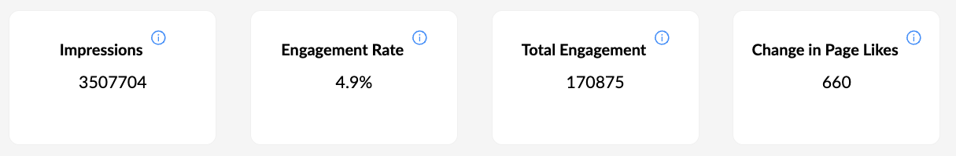

**Most popular May 1 - July 31 FB posts:**

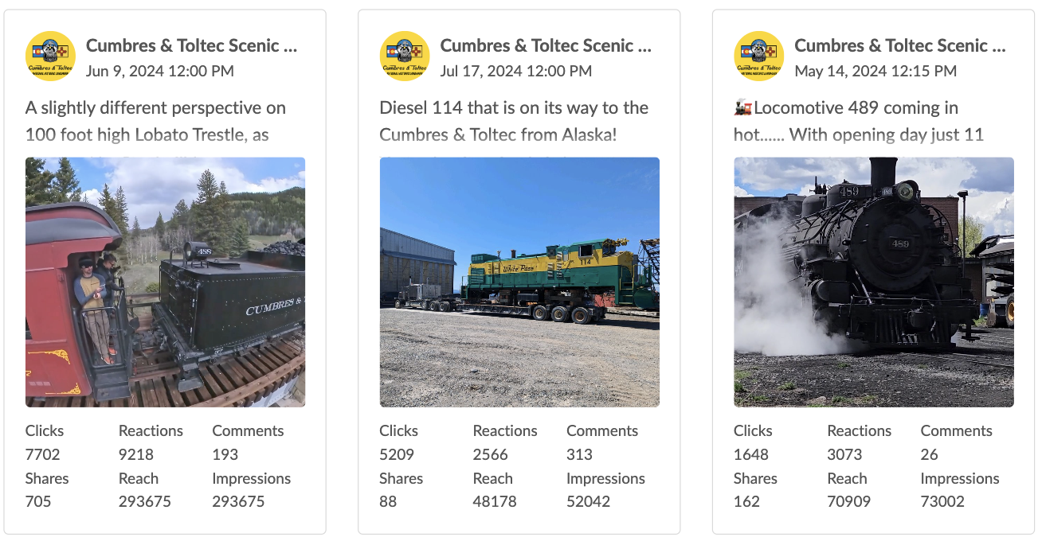

**MAY, JUNE + JULY INSTAGRAM OVERVIEW**

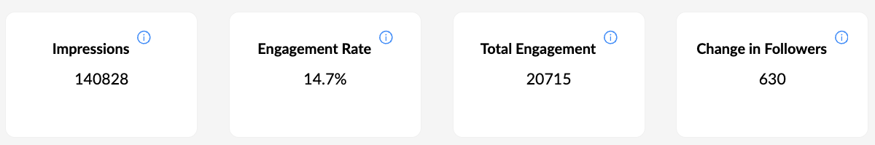

**Most popular May 1 - July 31 Instagram posts:**

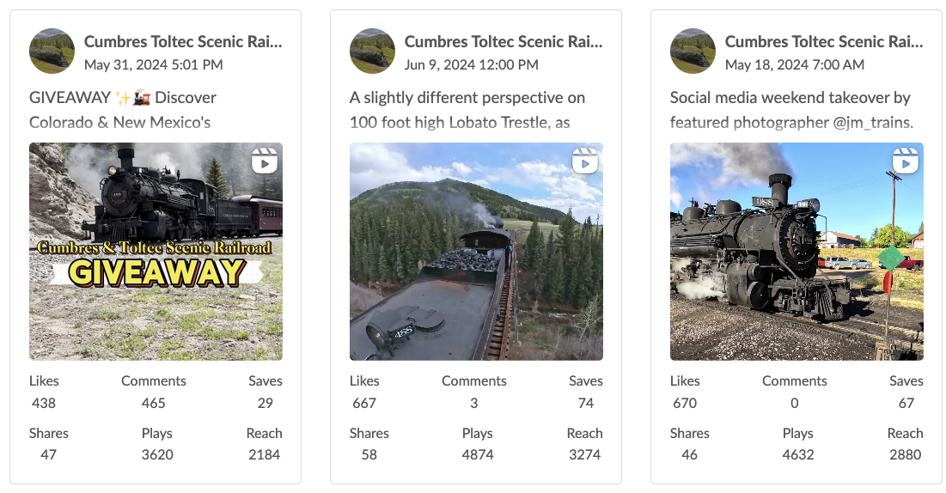

**WEBSITE**

Website traffic is up about 40% over the last 60 days. Our website averages about 9K users per week.

**KOB & OLYMPICS**

KOB – NBC Channel 4 TV out of Albuquerque aired our commercial 10x bonus during Olympic primetime during opening weekend of Olympics.

**TRENDS**

As we experience last season, we are seeing some similar trends during our 2024 season. The demographic ridership is a bit younger between the ages 40-50. In prior seasons, our guests would book two to three weeks ahead of their trip. This season we are seeing our guests book tickets a couple days before their departure and even the night before or morning of. The number of walk-ups has increased significantly. Overnight to morning of sales, can be an additional 20-30 people. Internet bookings are now 67% vs. last year of 64%.

**Addendum C**

**Financial Report**

**Summary:** 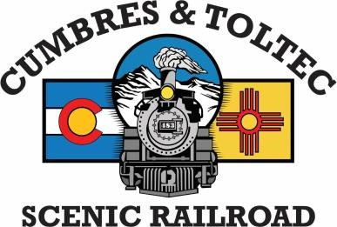

The finance department has been busy for the past couple of months. With the fiscal year ending and the new one has begun – we are working on ensuring we are prepped and ready for the annual fiscal financial audit. Accounts payable still has some invoices from fiscal year 2024 coming in. The month of June is about closed for fiscal year end. We are ensuring all adjustments for FY ’24 are completed before the trial balance is given to the auditors. Fiscal year 25 budgets are completed and will be reviewed and approved for the fiscal year. The financial statements that are provided, along with the summaries for June 30th, 2024, are unaudited at the moment. Inventory audit is completed as of June 30th, we will see the results of the inventory audit as we begin the financial audit.

**HPA:**

HPA for the month of June reflects the Historic Preservation Fee of $69,067.33 from operational trains. We also see the Management Liability expense of $2,267, which has increased from prior year. The increase is primarily due to the change of the policy period.

**Commission:**

Commission is quiet this time of year, although in July the support from NM for General Fund Support. Colorado will be invoiced for the General Fund Support. As of 06/30, there Commission trial balance will be ready for the auditors.

**CTO:**

In reviewing CTO, we are faced with the challenge of ensuring we are budgeting the correct number of riders for fiscal year 2025.

Revenue for fiscal year 2024 shows a decrease from prior year, but we also see a decrease in expenses as of 06/30 from prior year.

**Capital:**

As we spend down ARPA funds, we see a decrease in the Total Bank Accounts. We have expensed $1.454 of ARPA funds, which is a little less than half of the funds. Capital billing is billed up-to date through May 31st. As we finalize the trial balance and ensure all expenses: invoices, etc., are reflected on the June 30th billing for Colorado and New Mexico.

Alysia Martinez

CTO: Accounting & Finance Alysia Martinez 1

**Addendum D**

**Capital Projects Report**

Commissioner Gibbs

There was a lot of work performed over the last winter season.

Six steam locomotives operational

168 is ready for the post season photo trips.

463 has been operating at the east end of the RR. Last winter it received its five-year flexible staybolt inspection. Needs running gear work this coming winter, including driver tires.

484 also received its staybolt inspection. Doing two in one year was quite an accomplishment for the RR.

484 received a fair amount of running gear work.

487 received a huge amount of work. It was removed from service in 2021, due to star cracking around staybolt, the firebox sheets were incredibly thin. A new tender cistern, tender frame inspected and repaired repainted, a oil pumper installed with new piping, The lower 18 to 24 inches of the firebox were removed, new corners were fabricated, new sidesheets were fabricated, lower rear flue sheet, partial door sheet, then everything was re-riveted to the mud ring. A large throat sheet patch at the same time. There was an outer wrapper sheet patch around the engineers blowdown valve. The arch tubes were removed. It was converted to oil, using the D&S firepan design. Oil burner, firing valve, and all of the plumbing required to support the oil burner was installed. The butterfly fire doors were replaced with an air damper fire door. The front end was modified with a removal of the cyclone, replacement of the blast nozzle, and a new petticoat pipe for the oil drafting. The cross heads were refurbished. The piston rings were replaced. The cab was rebuilt with new wood, the floor and the walls. The locomotive was repainted. The plan is to test it with ballast trains in the near future. it is steamed up. Over the next few weeks, bugs will get sorted out. Once successful running ballast trains, it will be released to passenger service.

488 is in the normal service rotation.

489 received some modifications to its oil bunker to reduce water pickup in the fuel oil Avery’s folks made a change over the winter that really improved the firing of that locomotive. He also found some additional work that needs to be done on the oil bunker. As Marvin mentioned,

114 is setting in Bellingham WA. It was barged to there from AK. The trucks are already in Antonito. The locomotive will be trucked to Antonito from WA once permits are secured. (Ed note: WA state permits are the pacing factor in the move). Lava tank work resumes later this month. There is architectural design work being done for replacement of the pavilion at Cumbres Pass (thank you NM).

Engineering evaluation of the Chama roundhouse has been submitted to Ed, to look at structural improvements

A new coach (#526). Over the winter, cars 292, 256 & 65 were repainted. The Osier dinning hall exterior walls were repainted last spring. Engineering evaluations to replace the culverts at Long Creek are complete. They date from the late 1930’s. They don’t last forever. There is going to be a significant expenditure to fix that problem

**(Report not submitted so taken from Internet Meeting by Sam Seiber)